LAB ASSIGNMENT – 6
AI-Based Code Completion
Working with suggestions for classes, loops and conditionals
Name | Ch.Anirudh Bharadwaj
Roll No. | 2503A52411
Branch / Section | Bacth 14
1. Learning Outcomes
- Use AI-based code completion tools to generate Python code involving classes, loops, and conditionals.
- Interpret and explain AI-generated code line-by-line.
- Identify errors, inefficiencies, or logical flaws in AI-suggested implementations.
- Optimize AI-generated code for better readability and performance.
- Demonstrate ethical and responsible use of AI tools in coding tasks.
Task 1 – AI-Based Code Completion for Loops
Task: Generate Python code to print all even numbers between 1 and N using a loop.
Prompt:
Generate Python code to print all even numbers between 1 and N using a loop.
Python Code:
n = int(input("Enter N: "))
print("Even numbers between 1 and", n, ":")
for i in range(2, n + 1, 2):
print(i, end=" ")
Expected Output:
Enter N: 20
Even numbers between 1 and 20:
2 4 6 8 10 12 14 16 18 20
Explanation / Validation: Loop type: for loop. The range starts at 2 and advances by 2, so only even numbers are printed.
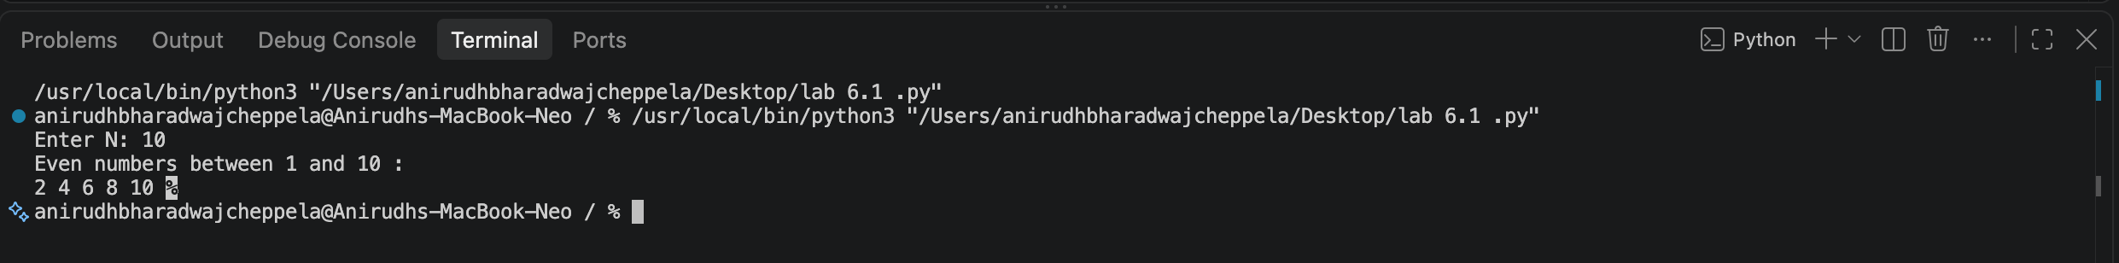
Task 2 – AI-Based Code Completion for Loop with Conditionals
Task: Generate Python code to count how many numbers in a list are even and odd.
Prompt:
Generate Python code to count how many numbers in a list are even and odd.
Python Code:
numbers = [10, 15, 22, 33, 40, 51, 68, 77]
even_count = 0
odd_count = 0
for number in numbers:
if number % 2 == 0:
even_count += 1
else:
odd_count += 1
print("List:", numbers)
print("Even numbers:", even_count)
print("Odd numbers:", odd_count)
Expected Output:
List: [10, 15, 22, 33, 40, 51, 68, 77]
Even numbers: 4
Odd numbers: 4
Explanation / Validation: Logic flow: the loop visits each element and the if condition checks divisibility by 2.
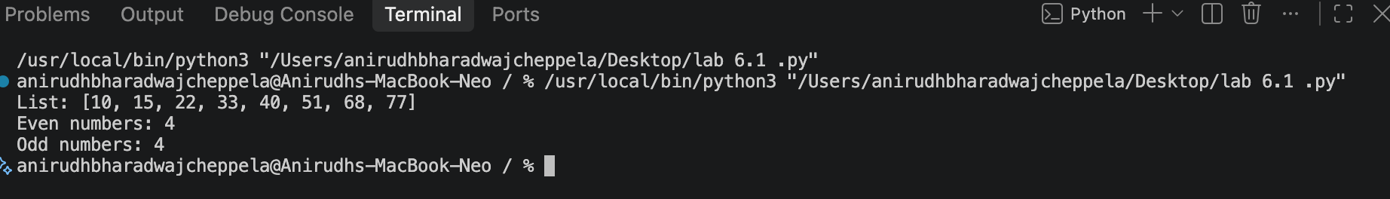
Task 3 – AI-Based Code Completion for Class Attributes Validation
Task: Generate a Python class User that validates age and email using conditional statements.
Prompt:
Generate a Python class User that validates age and email using conditional statements.
Python Code:
class User:
def __init__(self, age, email):
self.age = age
self.email = email
def validate(self):
age_valid = 18 <= self.age <= 100
email_valid = "@" in self.email and "." in self.email
if age_valid and email_valid:
return "User details are valid."
elif not age_valid and not email_valid:
return "Invalid age and email."
elif not age_valid:
return "Invalid age."
else:
return "Invalid email."
tests = [
User(20, "student@example.com"),
User(15, "student@example.com"),
User(25, "studentexample.com")
]
for user in tests:
print(user.validate())
Expected Output:
User details are valid.
Invalid age.
Invalid email.
Explanation / Validation: Validation uses conditional statements for age and a basic email-format check. Test cases cover valid and invalid inputs.
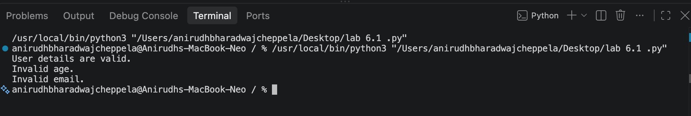
Task 4 – AI-Based Code Completion for Classes
Task: Generate a Python class Student with attributes (name, roll number, marks) and methods to calculate total and average marks.
Prompt:
Generate a Python class Student with attributes (name, roll number, marks) and methods to calculate total and average marks.
Python Code:
class Student:
def __init__(self, name, roll_number, marks):
self.name = name
self.roll_number = roll_number
self.marks = marks
def total_marks(self):
return sum(self.marks)
def average_marks(self):
if not self.marks:
return 0
return self.total_marks() / len(self.marks)
def display(self):
print("Name:", self.name)
print("Roll Number:", self.roll_number)
print("Marks:", self.marks)
print("Total:", self.total_marks())
print("Average:", self.average_marks())
student = Student("Anirudh", "21", [85, 90, 78, 88, 92])
student.display()
Expected Output:
Name: Anirudh
Roll Number: 21
Marks: [85, 90, 78, 88, 92]
Total: 433
Average: 86.6
Explanation / Validation: Manual improvement: an empty-mark list is handled safely, and the display method makes verification clearer.
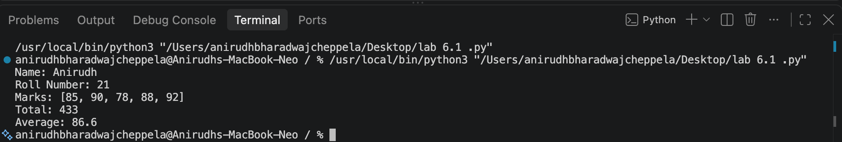
Task 5 – AI-Assisted Code Completion Review
Task: Generate a Python program for a simple bank account system using class, loops, and conditional statements.
Prompt:
Generate a Python program for a simple bank account system using class, loops, and conditional statements.
Python Code:
class BankAccount:
def __init__(self, name, balance=0):
self.name = name
self.balance = balance
def deposit(self, amount):
if amount > 0:
self.balance += amount
print("Deposit successful.")
else:
print("Invalid deposit amount.")
def withdraw(self, amount):
if 0 < amount <= self.balance:
self.balance -= amount
print("Withdrawal successful.")
else:
print("Invalid amount or insufficient balance.")
def display(self):
print("Account holder:", self.name)
print("Balance:", self.balance)
account = BankAccount("Anirudh", 5000)
while True:
print("\n1. Deposit")
print("2. Withdraw")
print("3. Display Balance")
print("4. Exit")
choice = input("Enter choice: ")
if choice == "1":
amount = float(input("Enter deposit amount: "))
account.deposit(amount)
elif choice == "2":
amount = float(input("Enter withdrawal amount: "))
account.withdraw(amount)
elif choice == "3":
account.display()
elif choice == "4":
print("Thank you.")
break
else:
print("Invalid choice.")
Expected Output:
1. Deposit
2. Withdraw
3. Display Balance
4. Exit
Enter choice: 3
Account holder: Anirudh
Balance: 5000
Enter choice: 4
Thank you.
Explanation / Validation: Strengths: quickly combines a class, loop, and conditionals into a working structure. Limitations: AI output still needs testing, validation, and security review before real-world use.
6. Overall Review
Area | Observation | Responsible Practice
Code completion | AI can quickly generate loops, conditionals and classes. | Read and test generated code instead of accepting it blindly.
Correctness | Generated code may contain logical or edge-case errors. | Validate with multiple test cases.
Readability | Comments and meaningful names make AI code easier to understand. | Refactor unclear code where needed.
Ethics | AI assistance does not remove developer responsibility. | Review, verify and use AI responsibly.
7. Conclusion
AI-based code completion can improve coding productivity by providing a starting implementation for loops, conditionals and classes. However, generated code must be interpreted, tested, reviewed for logical flaws, and improved for readability and performance. Responsible AI-assisted development keeps the human developer accountable for the final code.

